Name : Soumya Dixit

PRN : 23070521151

Sem : 5

Batch : B2

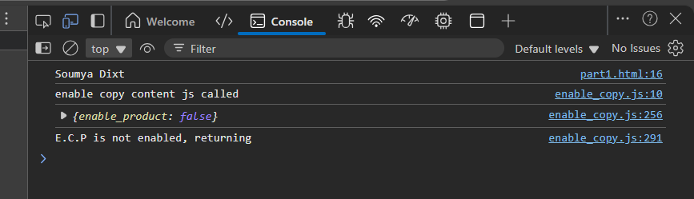

<script>

let name = " souMYa dIxt ";

name = name.trim();

let parts = name.split(" ");

let formatted = parts.map(

word => word.charAt(0).toUpperCase() + word.slice(1).toLowerCase()

).join(" ");

console.log(formatted);

</script>

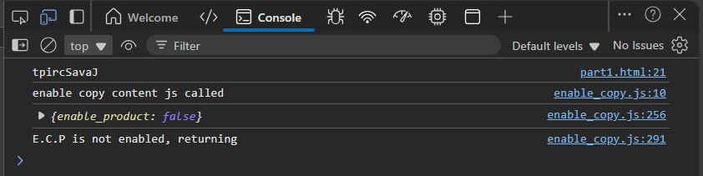

let str = "JavaScript";

let reversed = str.split("").reverse().join("");

console.log(reversed);

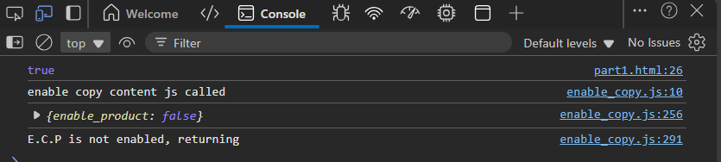

let email = "student@example.com";

let isValid = /^[A-Za-z0-9._%+-]+@[A-Za-z0-9.-]+\.[A-Za-z]{2,}$/.test(email);

console.log(isValid);

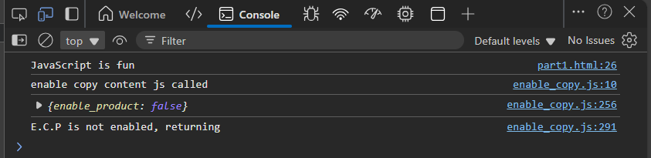

let messy = "JavaScript is fun";

let clean = messy.replace(/\s+/g, " ");

console.log(clean);

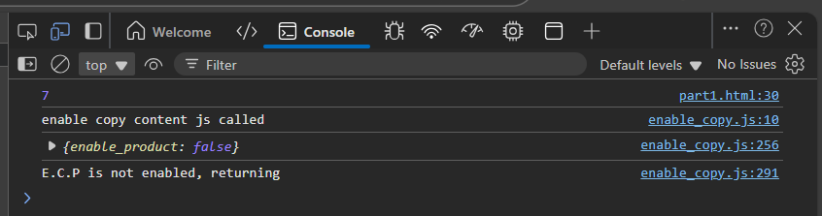

let sentence2 = "Hello world, welcome to the JavaScript lab";

let words = sentence2.trim().split(/\s+/);

console.log(words.length);